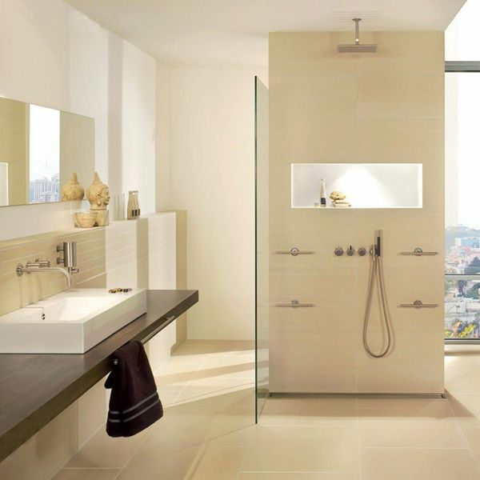**Lounge Polished Ivory Tiles:**

## **Product Description**

Create a stunning natural look in your home with the introduction of these Polished Ivory Floor Tiles. They belong to our selection of Lounge Tiles and have a durable porcelain body - ideal for use throughout the home, and even in areas with high footfall, such as the hallway. Their polished finish shimmers under the light - giving your floor areas an eye-catching appeal. Their ivory stone effect design is ideal for welcoming the sought after natural look into an interior setting. Why is the natural look such a popular interior design trend? Because it enables us to feel closer to nature in our homes - and therefore more at ease.

Due to the natural properties of polished porcelain tiles, we recommend using [LTP MPG](https://www.wallsandfloors.co.uk/catrangetiles/tile-preparation/ltp-cleaning-tile-protecting-tiles/ltp-mpg-sealer-1ltr-sealer-tiles/17683/) colourless impregnating sealer, which is specially formulated to protect and seal polished porcelain tiles.

To prevent staining, we highly recommend sealing these tiles with an [LTP MPG Sealer](https://www.wallsandfloors.co.uk/ltp-cleaning-protecting-ltp-mpg-tile-sealer-11270), both before and after grouting. This can be applied as per the manufacturer’s instructions using an [LTP Buffing Cloth](https://ww2.wallsandfloors.co.uk/ltp-maintenance-tools-blue-buffing-cloth-2-pack). For everyday cleaning, we only recommend [LTP Waxwash](https://www.wallsandfloors.co.uk/ltp-cleaning-protecting-ltp-waxwash-tile-maintenance). Please refer to this [downloadable maintenance PDF](https://www.wallsandfloors.co.uk/media/catalog/product/polished-porcelain-maintenance-cleaning.pdf).

## **Product Info**

* Product ID 11202
* Tiles Per SQM 2.7777777777778
* Sale by Per SQM
* Size 600x600x9mm
* Weight 8.63 KG
* Material Type Porcelain
* Finish Polished
* Colour Beige/Ivory
* Suitability Floors, Walls
* Grade 5
* Rectified Edge No
* Underfloor Heating Yes
* Document [Sealing and Maintenance Guide](https://m2.wallsandfloors.co.uk/media/amasty/amfile/attach/polished-porcelain-maintenance-cleaning.pdf),[Sealing and Maintence Guide](https://m2.wallsandfloors.co.uk/media/amasty/amfile/attach/ltp_polished_porcelain_data_sheet.pdf)
* Thickness (mm) 9